AUTH-019
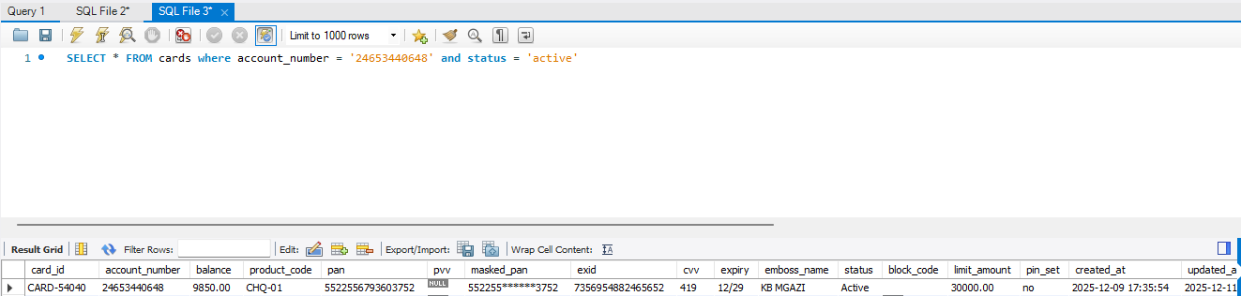
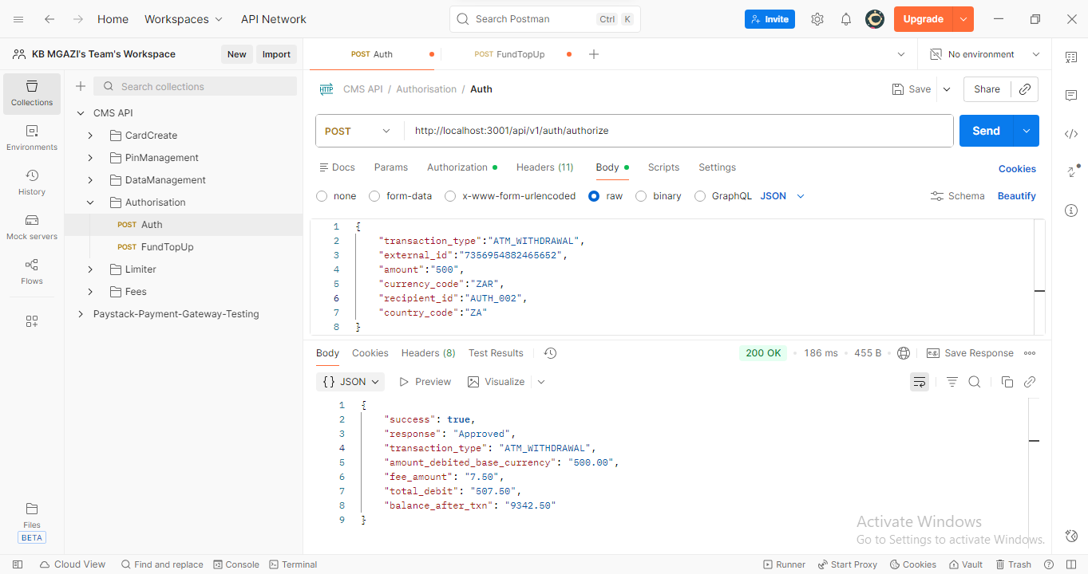
Request:
{
"transaction_type":"ATM_WITHDRAWAL",
"external_id":"7356954882465652",
"amount":"500",
"currency_code":"ZAR",
"recipient_id":"AUTH_002",
"country_code":"ZA"
}
Response:
{
"success": true,
"response": "Approved",
"transaction_type": "ATM_WITHDRAWAL",
"amount_debited_base_currency": "500.00",
"fee_amount": "7.50",
"total_debit": "507.50",
"balance_after_txn": "9342.50"
}
